SQL Exercise 6

**Purpose:** Nine SQL exercises will be released throughout the quarter. These assignments will help you connect and manipulate a database through Python. Python-to-SQL is a parallel strand of knowledge that you would gain in this class.

**Reference:** 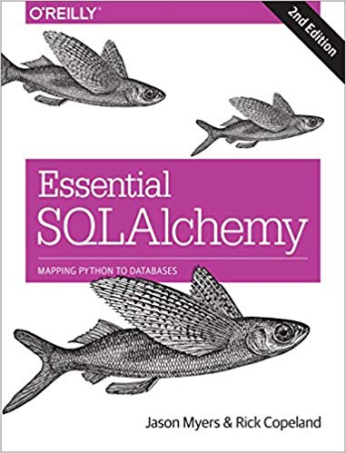

**Code:** Time to practice! Try the code below and get it to work. The code is pre-tested and should run “as is.” Verify what you type if an error persists. Press “Run” to every time you completed a jupyter cell. Because you already have content knowledge of what is a database, most of the code are self-explanatory.

***Instructions:*** *Start a new Python project folder … do not reuse the previous workspace … As with any keyboard-driven console-like environment, developing muscle -memory for the common commands is also part of the learning curve.*

**Viewing database:** To view the database created by Python, you may use a SQL Lite viewer. This tool is posted inside Week #2 in Canvas; look for DB.Browser.for.SQLite-3.10.1-win64

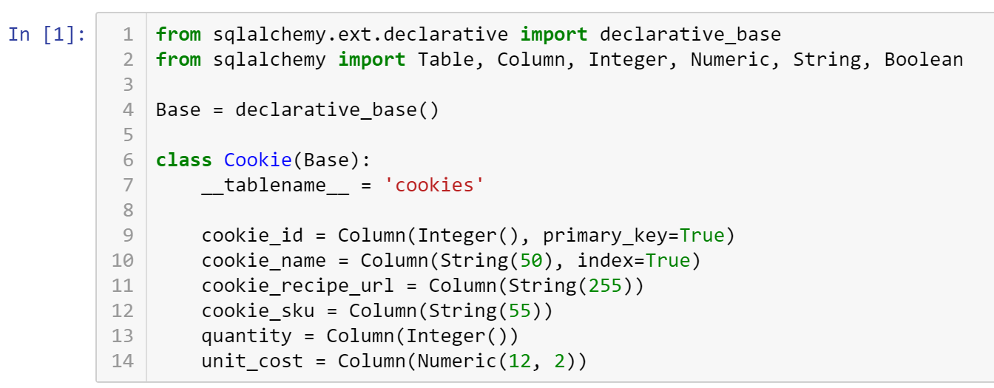



Table('cookies', MetaData(bind=None), Column('cookie_id', Integer(), table=<cookies>, primary_key=True, nullable=False), Column('cookie_name', String(length=50), table=<cookies>), Column('cookie_recipe_url', String(length=255), table=<cookies>), Column('cookie_sku', String(length=55), table=<cookies>), Column('quantity', Integer(), table=<cookies>), Column('unit_cost', Numeric(precision=12, scale=2), table=<cookies>), schema=None)

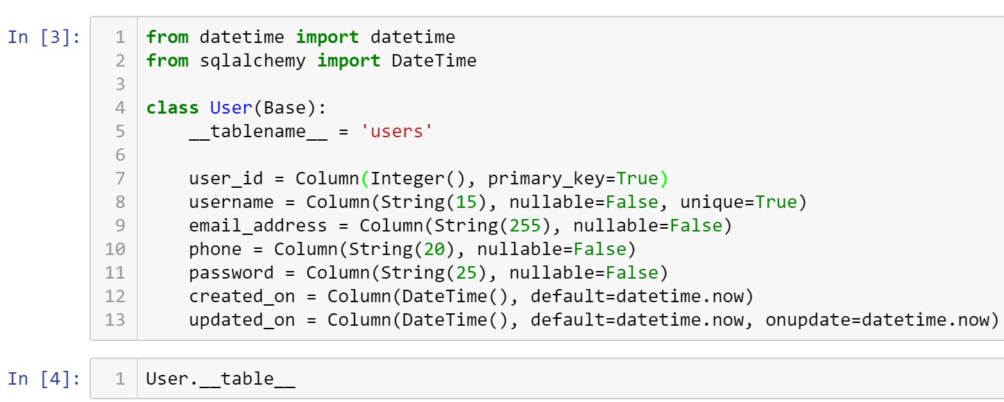

Table('users', MetaData(bind=None), Column('user_id', Integer(), table=<users>, primary_key=True, nullable=False), Column('username', String(length=15), table=<users>, nullable=False), Column('email_address', String(length=255), table=<users>, nullable=False), Column('phone', String(length=20), table=<users>, nullable=False), Column('password', String(length=25), table=<users>, nullable=False), Column('created_on', DateTime(), table=<users>, default=ColumnDefault(<function <lambda> at 0x1124c30c8>)), Column('updated_on', DateTime(), table=<users>, onupdate=ColumnDefault(<function <lambda> at 0x112488d70>), default=ColumnDefault(<function <lambda> at 0x112488de8>)), schema=None)

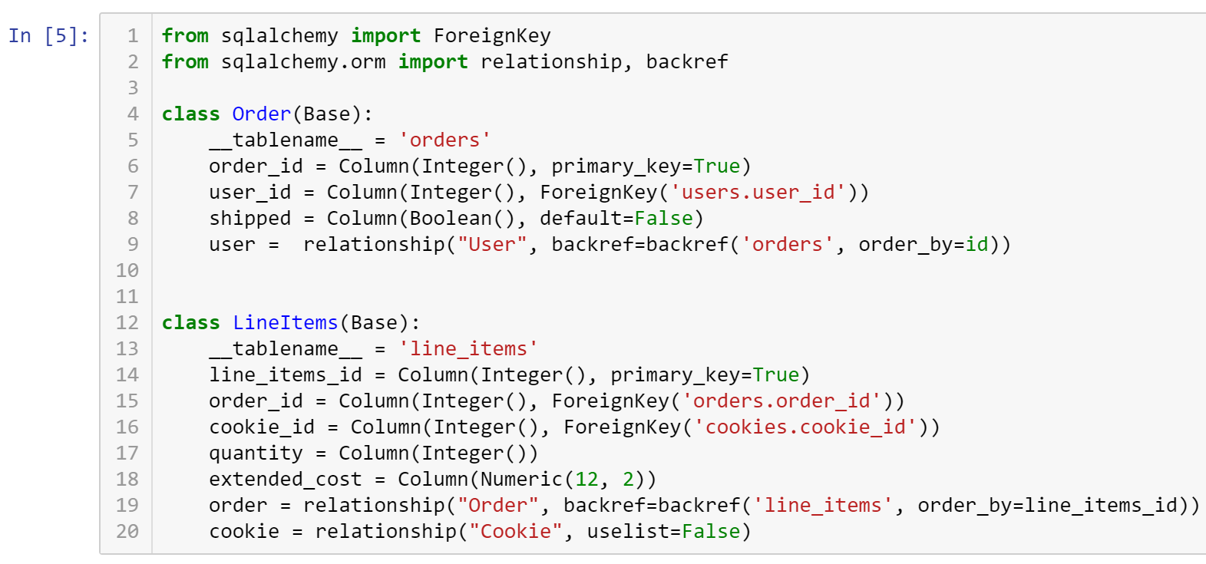

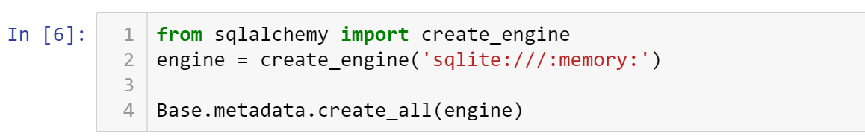

* **Critical Thinking Section:** In your own words, explain your understanding of the Python code:

engine = create_engine('sqlite:///:memory:')

* Write your answer in a paragraph (5 sentences or more) describing what you have learned from your research regarding this command.
* Place your answer here below:

|  |
| --- |
|  |

* Place your name at the bottom of your code, download your Python program in html format, and submit your work in Canvas.

**Viewing database:** To view the database created by Python, you may use a SQL Lite viewer. This tool is posted inside Week #2 in Canvas; look for DB.Browser.for.SQLite-3.10.1-win64

**Important:** All submissions should be separate from other exercises and quests. Please do not lump all your answers into one document and re-using that same workspace to gain multiple points. Thanks.